TECHNICAL SPECIFICATION
for spare parts supply
тЕХНИЧЕСКИ ДАННИ
ЗА ДОСТАВКА НА РЕЗЕРВНИ ЧАСТИ

Machinery: HIGH PREESURE WATER JET
Model/Type: FALCH G393 wheel jet 15
Serial № :
Built in: 2024
Manufacturer: FALCH GmBh
Address: 89143 blaubeuren-seissen (germany)
Parts Catalogue:

Pos | PART No | DESCRIPTION | Q’TY ordered
0 | E0113553 | REPAIR KIT | 2 бр.
0 | E0113554 | REPAIR KIT | 2 бр.
0 | E0113549 | REPAIR KIT | 2 бр.
 | E1700042 | Thermostat (56 °C, 1/2" ag) | 3 бр.
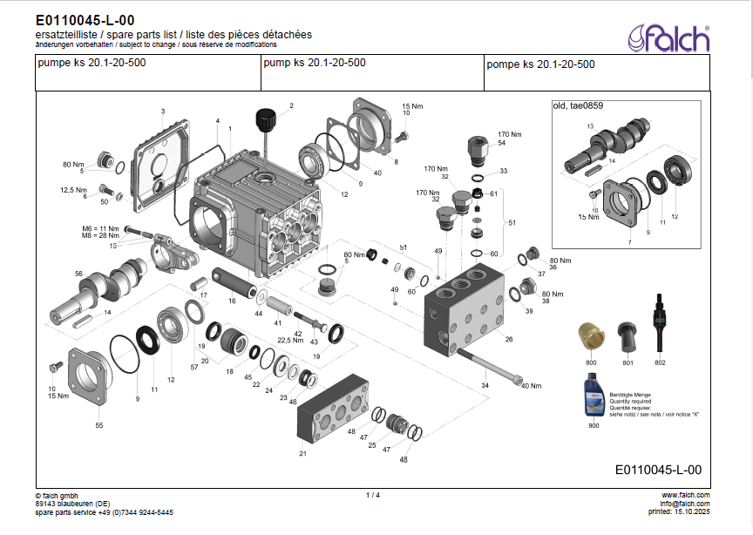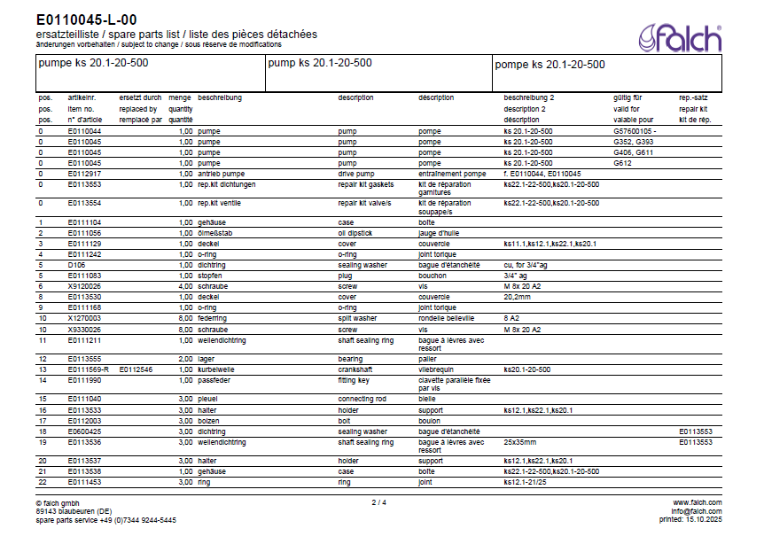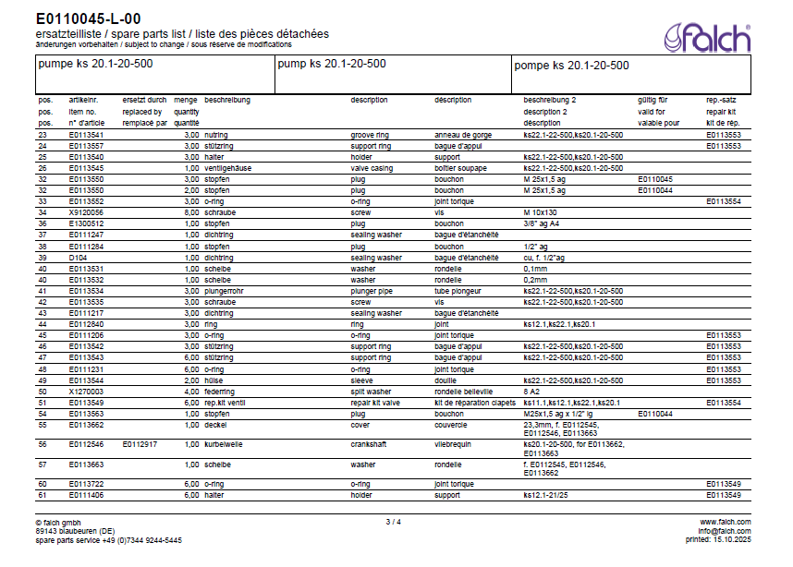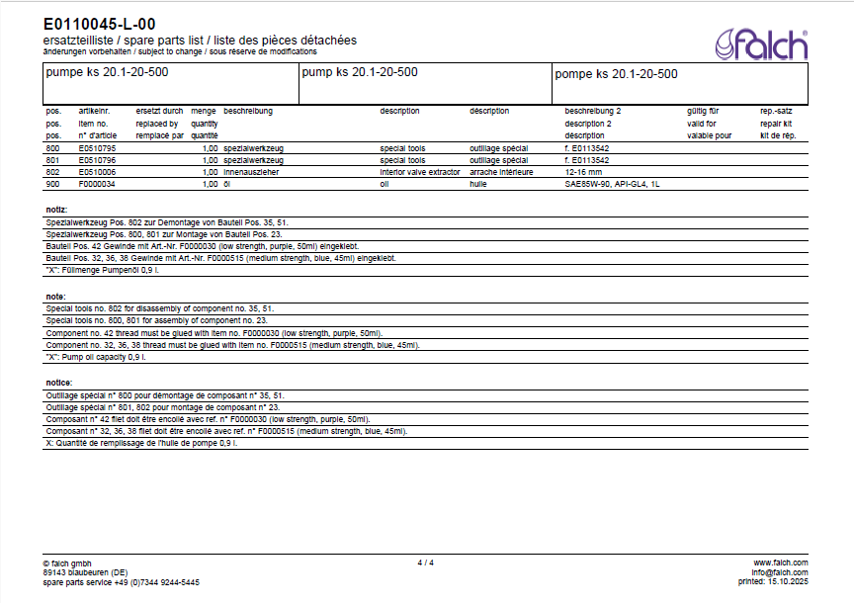
REMARK:
- CATALOG PAGES ATTACHED FOR REFFERENCE!!!
- Please mention in offer which parts are included in above repair kits.

ENQ №: KK1001/HPWJ | DATE: 28/10/2025 | Krasimir Kaludov

